**Hong Kong Neighborhoods**

Chan Chun Yin

July 25, 2020

**1.Introduction**

1.1 Background

Hong Kong is a place with the highest population density in the world and the unaffordable price for a flat. Therefore, looking for a lovely place to live is the top priority in Hongkongers’ and immigrants’ agenda. However, not just being survived, living in a place which can match your living style is also important. Also, it is also necessary for the one who wants to move to the similar places to know about the neighborhoods.

1.2 Interest

Obviously, Hong Kong people would be interested in the geospatial data. Others such as migrants maybe interested in this report when they are looking for a place to live in Hong Kong.

**2.Data acquisition and cleaning**

2.1 Data sources

The geodata of Hong Kong can be found on <https://geodata.gov.hk/gs/>?, to find different districts in Hong Kong. Second, nearby facilities of the districts can be found on Foursquare. Longitude and latitude data can be found by using geopy library.

2.2 Data cleansing

First, only the districts data was retrieved from the government page. Second, the clustering was based on top ten popular facilities within the districts.

3. Exploratory Data Analysis

https://github.com/cychan839/Coursera_Capstone/blob/master/Hong%20Kong%20Neighborhood.ipynb

4.Result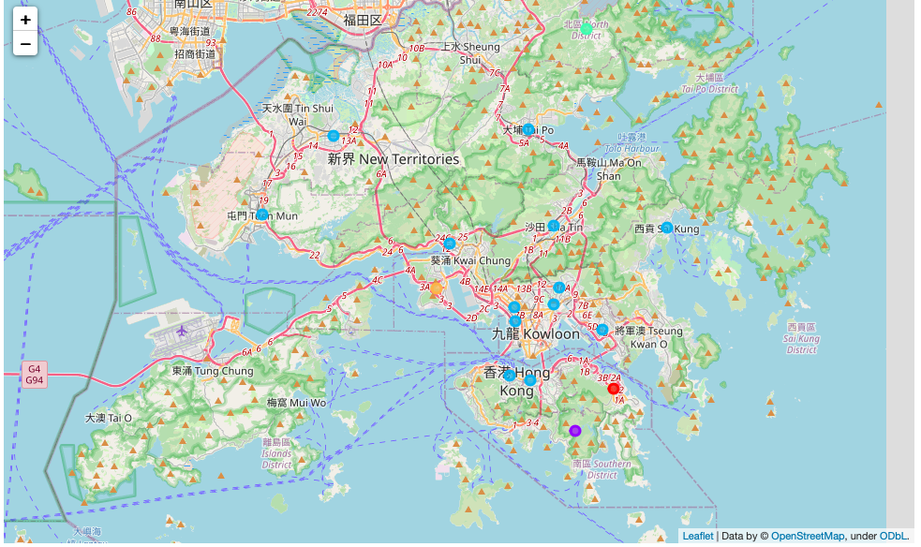

5.Conclusion

The clusters mainly divide 5 groups within Hong Kong. The facilities in the first cluster mostly are about Bus stop(due to remote location) and parks . Second cluster is about countryside such as reservoirs and zoo. The third cluster are the city center since most of the popular facilities are restaurant, Hotel and shops. The fourth cluster is about natural visiting places such as waterfall and zoo. The fifth cluster is a place which is far from city center with two tunnels connecting to main area.